Picture | Item code | Description | Sales price  EXW | Quantity  PU | Total qty
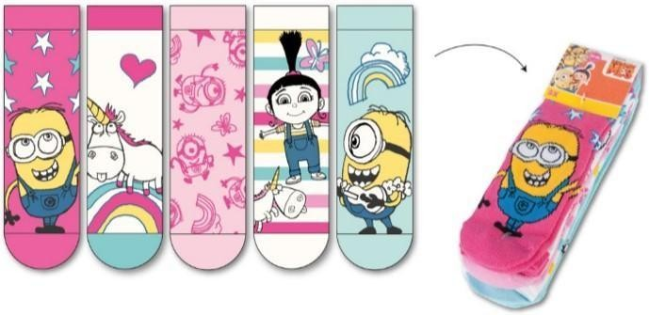 | YAB-68 | Minions, Kids socks for boys (pack of 5 socks) - assortment | € 1,89 | 15
 | YAB-69 | Minions, Kids socks for boys (pack of 5 socks) - solid size | € 1,89 | 70
Total qty |  |  |  |  | 120000
